Spyglass-Telescope
Every pirate needs a Spyglass-Telescope, and this one is movable too!
Here's what you'll need...
• Paper cup
• Toilet paper roll
• Construction paper
• Scissors
• Glue
• Black marker
Here's how you make it...
- Trace around the toilet paper roll on the bottom of your cup. Cut out the hole (this is where your roll will be inserted).
- Next you need to make a ring out of paper. Trace around the bottom of your cup. Place the toilet paper roll in the center of this tracing, and trace around the roll.
- Cut out your ring.
- Spread some glue around one end of the toilet paper roll and glue on the ring (the ring will stop the roll from coming out of the hole in the cup).
- Once the glue is dry, insert the toilet paper roll into the hole in the cup. Insert the end that does not have the ring attached.

Now you can move your spyglass-telescope in and out. Draw on some black lines around your scope if you wish.
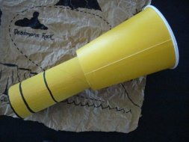

Pirate Eye Patch
- Black felt
- White puffy pain (optional)
- Back ribbon
- Scissors

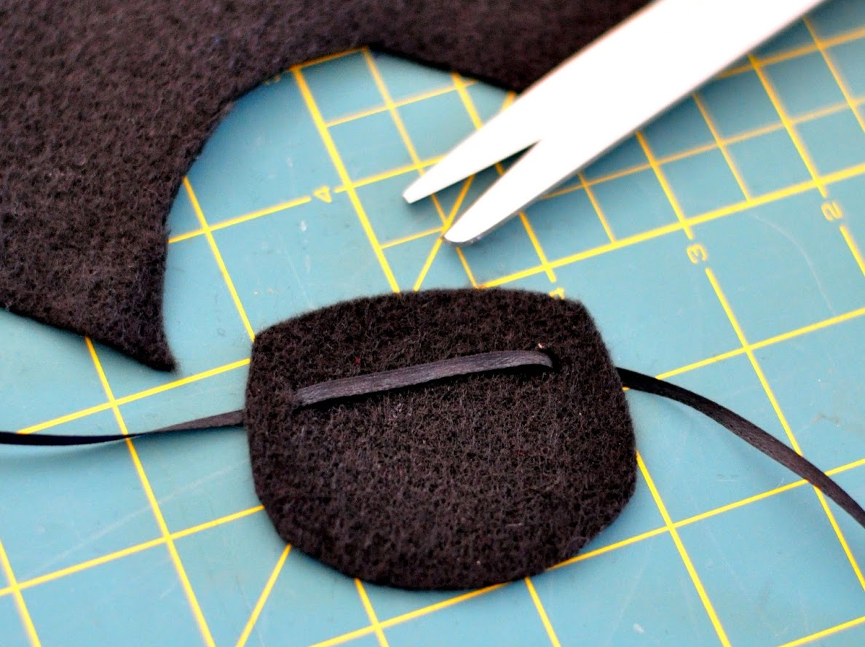
- Cut out eye patch shape from felt.
- Punch holes near the top edge on either side and thread ribbon through.
- If you want, decorate with a skull and crossbones in puffy paint.
- Tie it on your head and look tough.

Pirate Hats
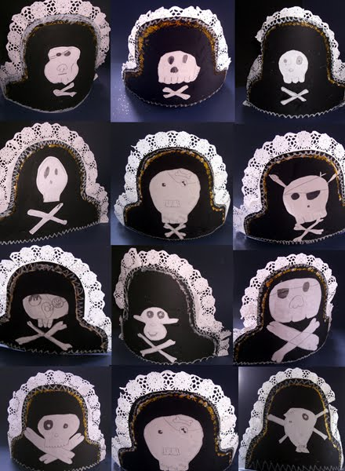
- Black posterboard hat template
- White lace trim
- Gold glitter (optional)
- White paper
- Black markers
- Glue

Directions
- On white paper, draw a Jolly Roger (skull and crossbones). Examples are provided, or do your own thing!
- Cut out your Jolly Roger and to it to the hat template.
- Glue your white lace trim along the top edge of the hat. Hot glue works very well for this, if you have it. If not, school glue is fine. You will just have to allow it to dry flat until the glue is completely set.
- (Optional) With school glue, make a line just under the lace and sprinkle with gold glitter. Tap off excess glitter onto paper and return to glitter jar. OR, use gold glitter glue.
- Get someone to help you measure your hat band. Glue the band to the hat (use hot glue if you have it; if not, use school glue and let dry before wearing.
- Put on your pirate hat and make someone walk the plank!
